SE PROJECT

SUBMITTED BY :   
HUSSAIN BASIT { F2023266143 }  
AHMED WAHEED { F2023266146 }

TALHA RASHEED { F2023266105 }  
SUBHAN AKRAM { F2023266120 }

**Employee Hiring Software to Prevent Favoritism**

**1. Objectives**

* **Eliminate Bias and Favoritism:** The software will anonymize candidate profiles and ensure decisions are made based purely on qualifications, experience, and fit for the role.
* **Ensure Fair and Transparent Hiring:** AI-driven evaluations will ensure fairness in the assessment process, making it easier to track, audit, and review decisions.
* **Streamline Recruitment Workflow:** Automate tasks such as resume screening, interview scheduling, and candidate evaluation, making the hiring process faster and more efficient.

**2. Ownership and Stakeholders**

**Ownership:**

* **Project Owner:** [Company/Department Name] - Oversees the overall project execution and ensures it meets company needs.
* **HR & Recruitment Teams:** Direct users of the software, responsible for testing, feedback, and adoption of the system.

**Key Stakeholders:**

* **Hiring Managers:** Primary users who will interact with the system to assess candidates.
* **Candidates:** Indirect stakeholders whose applications will be processed by the system.
* **Compliance and Legal Teams:** Ensuring the system adheres to legal and regulatory standards (e.g., data privacy, anti-discrimination laws).
* **IT/Infrastructure Teams:** Support in ensuring the system integrates seamlessly with existing platforms and meets security standards.

**3. Platform Choice**

The software will be a **cloud-based solution**, enabling scalability, security, and remote accessibility. The cloud platform will ensure seamless integration with existing HR management systems and offer flexibility for future upgrades.

**4. System Requirements**

**Functional Requirements:**

1. **Candidate Profile Anonymization:** The system will automatically anonymize candidate data (e.g., name, gender, age) to ensure unbiased screening.
2. **AI Resume Screening:** Use AI algorithms to automatically scan, analyze, and rank resumes based on job relevance and qualifications.
3. **AI Interview Analysis:** Conduct automated interviews or analyze video/text-based responses using AI to evaluate candidate responses, focusing on skills and potential.
4. **Bias-Free Ranking and Scoring:** The system will provide objective candidate scoring based purely on qualifications and interview performance.

**Non-Functional Requirements:**

1. **Scalability:** The system should scale to handle multiple job openings and large volumes of applicants.
2. **User Accessibility:** The platform should be user-friendly and accessible across various devices.
3. **System Performance:** The software must ensure quick response times, especially for resume screening and candidate evaluation.

**5. User Requirements**

**For HR Managers and Hiring Teams:**

1. Ability to upload job descriptions and define role requirements.
2. Access to anonymous candidate profiles for unbiased assessment.
3. Tools to review AI-generated recommendations for candidates.
4. Ability to provide feedback and conduct interviews via the platform.
5. Comprehensive reporting capabilities to track hiring metrics and decisions.

**For Candidates:**

1. A simple interface to submit applications.
2. Automated interview scheduling and communication through the platform.
3. Transparency on how their application is evaluated.

**6. Conclusion**

This software solution will transform the hiring process by ensuring fairness and efficiency in recruitment. By integrating AI tools to screen resumes and analyze interviews, the system will eliminate biases and promote a merit-based selection process. The cloud-based nature of the platform offers flexibility, scalability, and ease of access, while robust reporting features ensure accountability and transparency in every step of the hiring journey.

We are confident that this system will significantly improve the recruitment process by making it faster, more objective, and free from favoritism.

USE CASE DIAGRAMS :

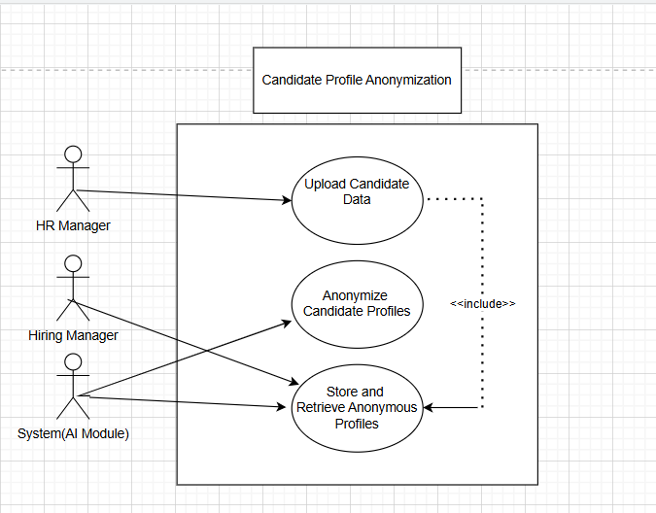

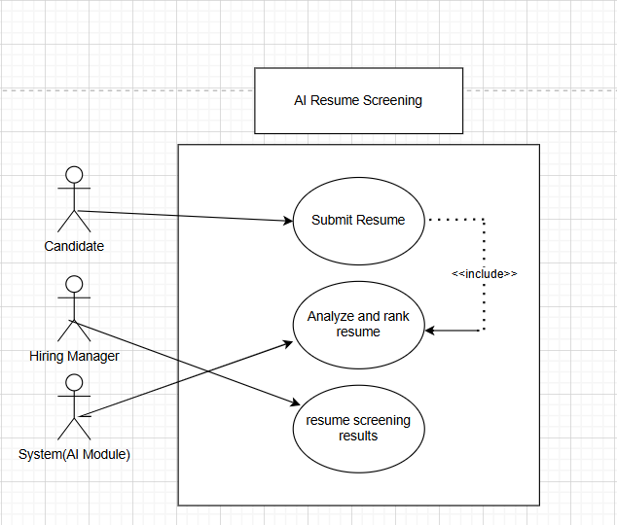

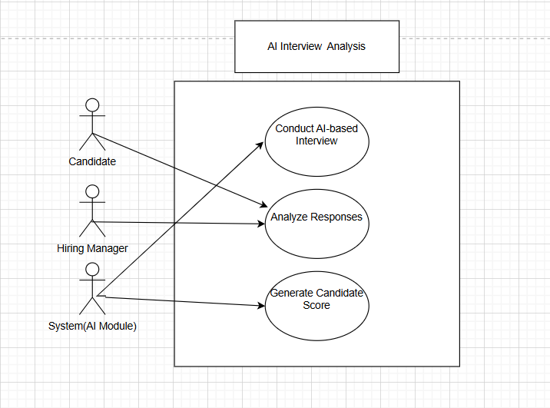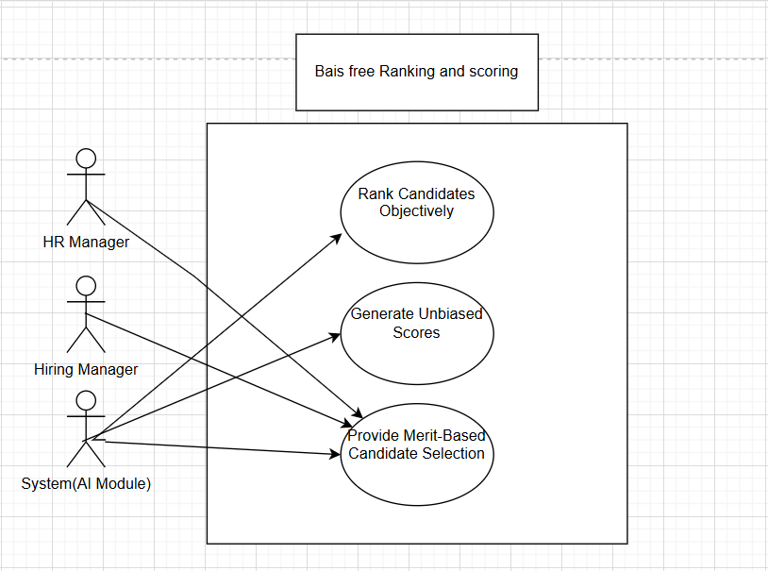

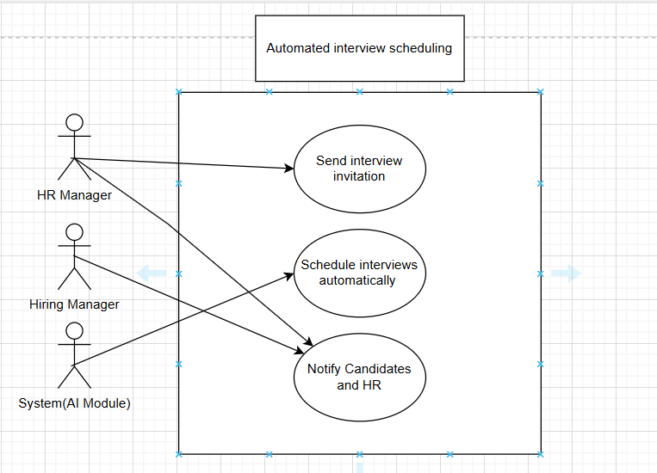

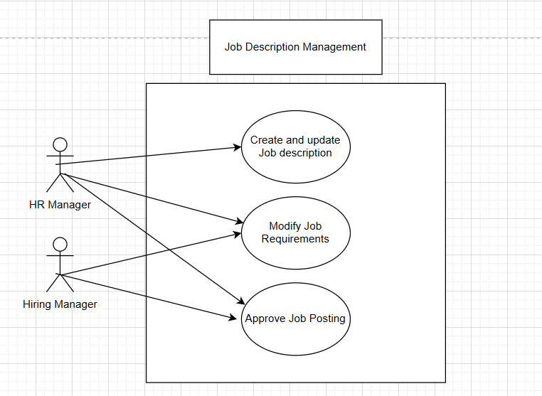

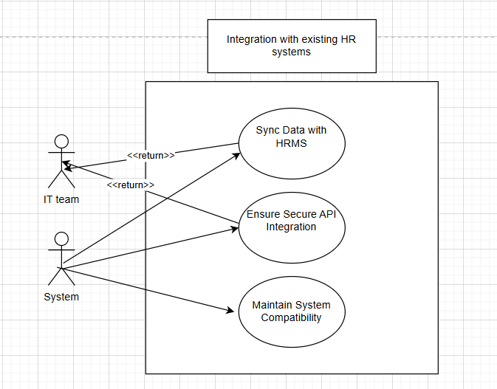

**STATE DIAGRAM :**   
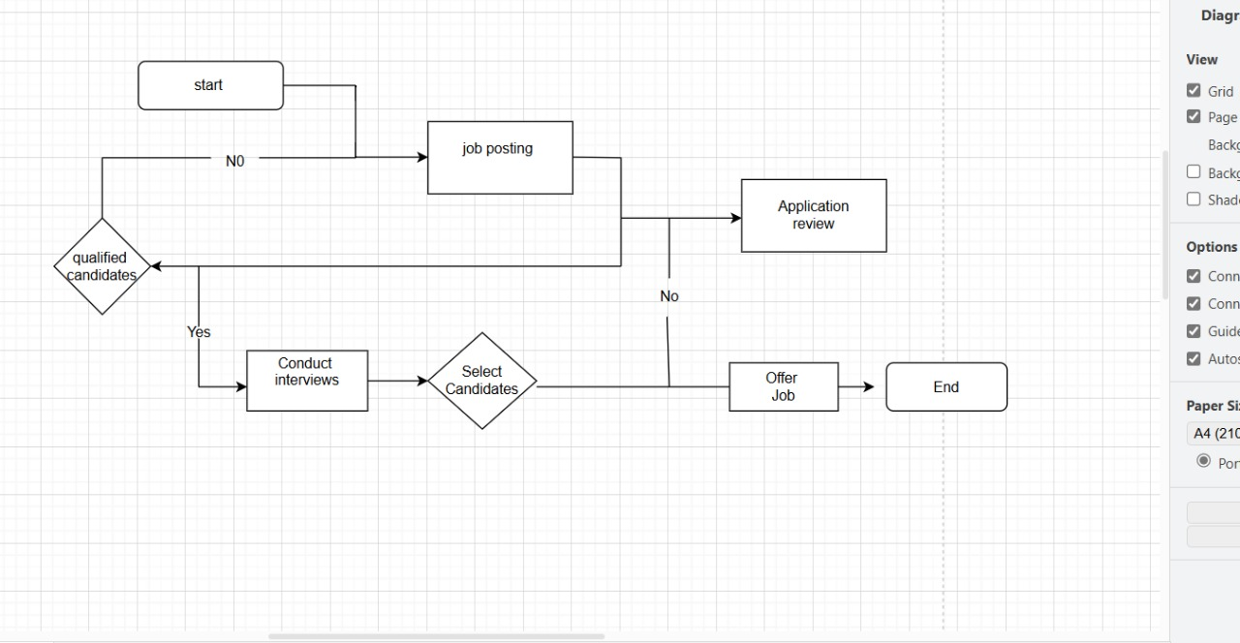

**ERD DIAGRAM :**

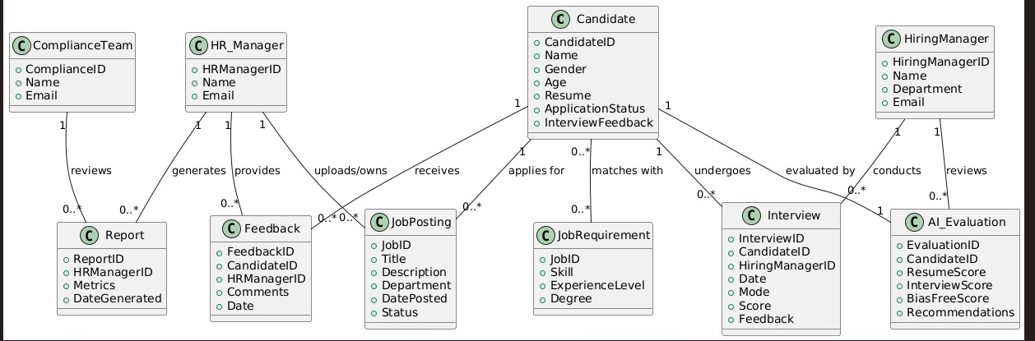

**Gantt Chart:**

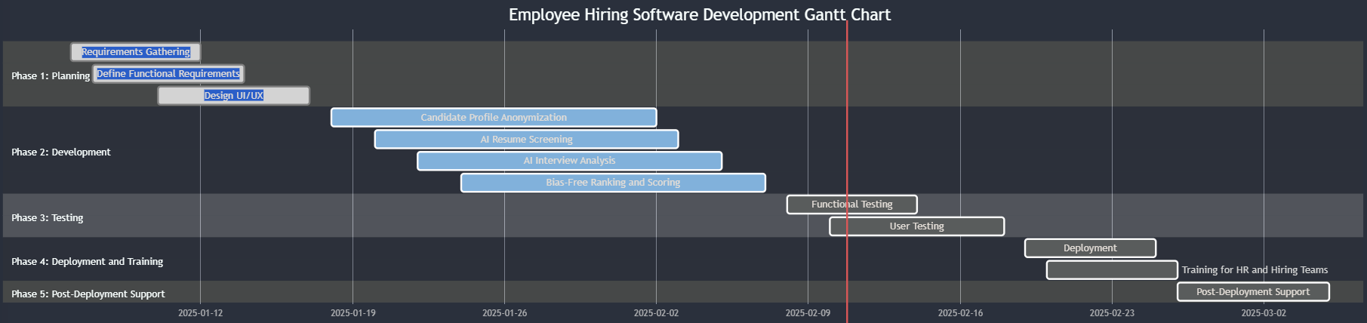

**Sequence Diagram**

